Solution Design Document

KCH

ORACLE RECRUITMENT CLOUD

Author :

Creation Date: 18th October 2023

Last Updated: 27th December 2023

Document Ref: Latest Release

Version : V1.1

# Document Control

## Change Record

|  |  |  |  |
| --- | --- | --- | --- |
| Version No. | Date | Amendment History | Remarks |
| V1.0 | 18-Oct- 2023 | No Previous Version | Based on HLA discussion |
| V1.1 | 27-Dec-2023 | V1.0 | Based on CRP-2 |
|  |  |  |  |
|  |  |  |  |
|  |  |  |  |

## Reviewers

| Name | Organization | Position |
| --- | --- | --- |
|  | Mastek | Solution Architect |
|  | Mastek | Project Manager |
|  | Mastek | Program Manager |
|  | KCH | Business Specialist |
|  | KCH | Project Manager |

1. **Title, Subject, Last Updated Date, Reference Number**, **and** **Version** are marked by a Word Bookmark so that they can be easily reproduced in the header and footer of documents. When you change any of these values, be careful not to accidentally delete the bookmark. **You can make bookmarks visible by selecting the Office Button>Word Options>Advanced> and checking the Show bookmarks option in the Show document content region.**
2. **Title, Subject, Last Updated Date, Reference Number**, **and** **Version** are marked by a Word Bookmark so that they can be easily reproduced in the header and footer of documents. When you change any of these values, be careful not to accidentally delete the bookmark. **You can make bookmarks visible by selecting the Office Button>Word Options>Advanced> and checking the Show bookmarks option in the Show document content region.**

Content Page

1 Document Control 2

1.1 Change Record 2

1.2 Reviewers 2

2 Introduction 5

2.1 Purpose 5

2.2 How is this document organised: 5

2.3 Process Symbols 6

3 Introduction to Recruitment 7

4 Recruitment structural data 8

5 Process Step Description 8

5.1 Creation of Requisition 9

5.1.1 Requisition Creation Process 9

5.2 Manage Job Requisition 20

6 Candidate Application 20

6.1 Subscription of Talent Community by Candidate 20

6.1.1 Process Description 20

6.2 Candidate Sourcing by Recruiter/Agency 21

6.2.1 Process Description 22

6.3 Candidate Application by Employee via Internal Job Portal 23

6.3.1 Process Description 23

6.4 Candidate Application by Candidate (External Career Site) 24

6.4.1 Process Description 24

6.5 Candidate Application by Recruiter 26

6.5.1 Process Description 26

7 Manage Candidate Application 28

7.1 Manage Candidate Selection Process 28

7.1.1 Process Description 28

7.2 Offer RMI/Post Offer Pre-hire Onboarding. 29

7.2.1 Pre-Offer RMI 29

7.2.2 Post offer Pre-hire Onboarding 29

8 Manage Interview 30

8.1 Schedule an Interview 30

8.1.1 Process Description 31

8.2 Update and Cancel Interview 31

8.2.1 Process Description 32

9 Interview Feedback Form 33

10 Manage Job Offer 35

10.1 Create Job Offer 35

10.1.1 Process Description 35

10.2 Job Offer Fields 37

10.3 Job Offer Template 39

11 Candidate Management and Pools 40

11.1 Candidate Search and View 40

11.1.1 Process Description 40

11.2 Manage Candidate Pool 41

11.2.1 Process Description 41

12 Move to HR 42

13 Access and Approval Matrix 42

13.1 Access Matrix 42

13.2 Approval Matrix 44

14 Onboarding 44

15 Notifications 44

16 Deliverables Source 45

17 Sign Off Sheet 45

# Introduction

The recruitment process includes working with requisitions and tracking applicant information. You enter a requisition to begin the process of filling a vacancy within the organization. A requisition is a record or document that contains information about the open position (an employee assignment for a fiscal year) and job description (the duties that an employee performs for the organization).

This document provides KCH with Requisition Management, Candidate Management, Offer Process, and other requirements along with Fit gap analysis sections.

## Purpose

The purpose of this document is to describe the key business structural elements that affect subsequent set up of the application. This deliverable is used to assist in the development of application setup. It includes:

* Requisition Process
* Requisition Management
* Candidate Management
* Offer Management
* Career Sites
* Onboarding Process
* HLA/CRP-1 Decisions
* Open and Closed Points

## How is this document organised:

This document contains Oracle Recruitment management Processes, as the scope of this project.

* The requirement listing and requirement description table provides a name and description for each requirement provided. The table has the following columns.
  + **Req ID**: An Id to denote each requirement mentioned in BRD.
  + **Categorization:** Categorization done on basis of oracle standard terminologies.
  + **Req Description:** Detailed Description of the requirement.
  + **Mastek Understanding:** Mastek understanding and comments towards the subsequent requirement.
* The process listing and process description table provides a name and description for each process within the Function. The table has the following columns.
  + **Process ID**: An Id to denote each process.
  + **Process Title:** short description of the process.
  + **Description of the Process**: Detailed Description of the process.

The Process Id naming convention follows the following format.

Project Name Functional Area _Process Code _Serial Number

* The process step catalog identifies the process steps that form part of the business process. The table has the following columns.
  + **Process Step ID:** Process Step Id
  + **Process Description:** Records the process step as clearly as possible.
  + **Step Type:** Manual means it’s done outside the system, System assisted means step will be conducted within the system, System generated means it’s a system generated step and Decision means the action could be Yes or No,
  + **Output:** Output
  + **Expected Improvement from the Change:** Mention the Process improvement that will be achieved by the change.
* The Process Flow Diagram includes a diagrammatic representation of the process steps that form part of the business process.

An Introduction for each of the modules catering to the Functional Area is included at the beginning of the Chapter relating to the Functional Area.

## Process Symbols

The following symbols represent different actions/activities in a process flow, and it is included to facilitate process communication.

|  |  |
| --- | --- |
|  | This symbol represents a group of steps or activities to perform |
|  | This symbol represents a Decision. Decisions are typically phased as Yes / No Questions |
|  | This symbol represents information input/output such as report or document. This symbol does not always imply hard copy, as some are verbal |
|  | This symbol represents an offset page reference. Indicates a cross reference with another page of the flowchart |
|  | This symbol represents start and end of the process |
|  | This represents the input symbol of information entered the database |
|  | This represents manual operations. Manual operations are all parts of process which are carried outside the Oracle System |

# Introduction to Recruitment

This document contains the solution design and process as per the initial requirement gathering sessions.

This section provides the below details as per KCH recruiting structure:

* Job Requisition Management
* Hiring Management
* Candidate Management
* Candidate Job Application Management
* Candidate Selection Process
* Interview Management
* Job Offer Management.
* Approval Process
* Onboarding Process
* Agency and Agent Management
* Campaign Management
* Talent Community
* Talent Pool

This document will cover all process flows in detail in the following section. Along with other subjects of the solution individually.

# Recruitment structural data

This section of the document will be covering all the structural data, which would be the part of recruitment details, i.e., Organizations, Locations, Jobs, Positions, Grades, and other workforce related data. These details would be covered within CoreHR and transferred to Oracle Recruiting Cloud.

This section provides the below details as per KCH recruiting structure:

All core structural data for recruitment would transfer from COREHR to Oracle Recruiting Cloud. Any additional information can be captured within the recruiting extra information.

# Process Step Description

|  |  |  |
| --- | --- | --- |
| **Steps** | **Step Name** | **Process Description** |
| **01** | **Requisition Creation** | Requisition Creation is a shared process between Hiring manager and Recruiter, wherein Hiring Manager can create a requisition using Position/Template and will save the requisition. The Recruiter will receive the Notification to review the details, update the requisition. Organization will be defaulted based on position. |
| **02** | **Approval** | Recruiter will submit the requisition for approval from the Recruitment manager. |
| **03** | **Job Formatting** | In this step the Recruiter can add “Employer Description” and “Recruiting Organization Description” and “Media” links if any. |
| **04** | **Posting** | Recruiter can select the Job Boards on which recruiter will post the requisition. Example internal and external job boards, Agencies, or other job board like LinkedIn. Recruiter can also select agents to submit the candidate.   * One Internal Job Portal (For Employee Only) * One External Job Portal (For Candidate) |
| **05** | **Candidate Job Application** | 1. In Candidate Job Application Recruiter can create new candidate and submit their Job Application to any requisition. 2. Agency can submit the Candidate against the Invited Requisitions 3. External and Internal candidates can fill in the job application and submit the same. |
| **06** | **Candidate selection Process** | Candidate selection process is a process where candidate must go through some Stages to get hired like Inbox, Screening, 1st Interview, Second Interview, Offer, HR etc. Few stages can be skipped as all stages are not mandatory. |
| **07** | **Offer process** | In this Process, Offer Letter is generated based on details filled in the Offer Page and same will be sent for an Approval. Once Approved the Offer can be extended to the candidate for Acceptance |
| **08** | **Pre-Onboarding Process** | Recruiter will move candidate to HR and Pre-Onboarding checklist will get triggered and candidate will get converted to pending worker. |
| **09** | **Hire** | On-boarding team will convert the Pending work to Employee. Onboarding checklist will get triggered as soon as the candidate is converted as a Pending worker. |

## Creation of Requisition

A Requisition is a document that describe all the details required to capture a human resource need in the organization. In ORC the requisition form is a standard form which covers all the aspect of the requisition fields.

The requisition process is as follows:

* Hiring manager will raise a requisition, save, and close it.
* Recruiter will receive a notification to review the requisition and submit for an approval.

Once it is approved, Recruiter will receive the notification to do the job formatting and will post on career site, job boards.

### Requisition Creation Process



The above flow shows a process flow diagram to Create Job requisition in the system. Job Requisition will be created by Hiring manager/Recruiter. In case Job Requisition is already created and need an update only same can be done from the same page by searching the Job requisition to be updated.

**Process Input**

Information on Job Requisition such as:

* How
* Basic Info
* Requisition Structure
* Hiring Team
* Details
* Posting Description
* Offer Info
* Attachments
* Configuration (To be Filled by Recruiter)
* Questionnaires (To be filled by recruiter)

**Process Output**

**Upon Approval, Recruiter will be able to Post the new Job Requisition on different Job boards.**

#### Process Step Description

|  |  |  |
| --- | --- | --- |
| **Process Step** | **Process Description** | **Process Type** |
| CA_JR_01 | Hiring Manager will Create new Job Requisition. | System |
| CA_JR_02 | Create new Job requisition Hiring Manager will Initiate the Job requisition request by using Position and provide the details. | System |
| CA_JR_03 | Hiring Manager will save the requisition and the Recruiter will receive the notification. | System |
| CA_JR_04 | Recruiter will Review and update the requisition details. | System |
| CA_JR_05 | Recruiter will add questionnaire. | Manual |
| CA_JR_06 | Recruiter will add interview template. | Manual |
| CA_JR_07 | Recruiter will submit the transaction for approval. Once transaction is submitted, it is routed for approval process as per the approval matrix defined in the system | System |
| CA_JR_07.1 | Recruiter will do the job formatting. Employer description based on different countries and legal employer can done based on positions. | Manual |
| CA_JR_07.2 | Recruiter will then post job requisitions on Internal/External career sites, job boards like LinkedIn, Naukri etc. or recruiter can invite agency to submit the candidates. | Manual |

**\* Note: - In case Recruiter has any further clarification they can use Send Message option to communicate with Hiring Team.**

#### Requisition Fields

Requisition Form: In KCH the following requisition form with the fields will be created. The same will be used by Hiring Managers and Recruiters to fill in the requisition form.

|  |  |  |  |  |  |
| --- | --- | --- | --- | --- | --- |
| **Block Name** | **Name of Fields** | **Type of Field** | **Values** | **Mandatory** | **Comment** |
| **How Section** | | | | | |
| How | Requisition Type | Drop Down | * Standard * Pipeline | Yes |  |
| How | Use | Drop Down | * Position * Job * Template * Existing Requisition * Blank Requisition | Yes |  |
| How | Recruiting Type | Drop Down | * Campus * Career Event * Interns * Agency * Laterals * Movements * Professional | Yes |  |
| How | Primary Location | Drop Down | * Abu Dhabi * Ajman * Dubai * Fujairah * Ras Al Khaimah * Sharjah * Umm Al Quwain | Yes |  |
| How | Organization | Drop Down | * Information Technology * Business Systems, Information Technology * Clinical Systems, Information Technology * Network and Infrastructure, Information Technology | No |  |
| How | Requisition Template | Drop Down | List of all Template | Yes | On Selection of Template |
| How | Business Unit | Drop Down | Business Unit List | Yes | On Selection of Job or Position |
| How | Job | Drop Down | List of all Jobs | Yes | On Selection of Job |
| How | Position | Drop Down | List of all Positions | Yes | Position list will be visible based on persons position hierarchy |
| How | Requisition | Drop Down | List of all Active Requisition | Yes | On Selection of Existing Requisition |
| **Basic Information** | | | | | |
| Basic Information | Requisition Status | Read Only Field | Status of Requisition |  | Read Only Field |
| Basic Information | Requisition Type | Drop Down | Standard |  | Read Only Field |
| Basic Information | Requisition Title | Textbox | By Default, Position Name will be visible here | Yes |  |
| Basic Information | Number of Openings | Drop Down | * Limited * Unlimited | Yes | Defaulting from position headcount. |
| Basic Information | Position | LOV | Position Name | No | Read Only Field |
| Basic Information | Business Justification | Drop Down | * New Position * PT to FT * Promotion * Replacement * Reallocation * Transfer | No |  |
| Basic Information | Languages | Drop Down | * All * American English * Arabic | No | By Default, American English |
| **Hiring Team** | | | | | |
| Hiring Team | Hiring Manager | Drop Down | List of all Active Employees | Yes | Person name will be populated here who is raising the Requisition, however this is editable field |
| Hiring Team | Recruiter | Drop Down | List of all Active Employees | Yes | Based on AOR assigned to the Recruiters Smart List of Values can be displayed with Recruiter Name, however user can search for all employee |
| Hiring Team | Add Collaborator Type | Drop Down | * Collaborator | No |  |
| **Requisition Structure** | | | | | |
| Requisition Structure | Recruiting Type | Drop Down | * Campus * Career Event * Interns * Agency * Laterals * Movements * Professional | Yes | On Selection of Position |
| Requisition Structure | Organization | Defaulted | LOV | Yes |  |
| Requisition Structure | Primary Location | Defaulted | LOV | Yes |  |
| Requisition Structure | Job Family | Drop Down | List of all Job Family | Yes |  |
| **Details** | | | | | |
| Details | Employee Type | Drop Down | * Contingent * Employee | No |  |
| Details | Regular or Temporary | Drop Down | * Regular * Locum | Yes |  |
| **Posting Description (Visible to HM and Recruiter)** | | | | | |
| Posting Description | Internal Posting Description | Custom Box | * Short Description for Internal Candidates * Description for Internal Candidates * Responsibilities for Internal Candidates * Qualifications for Internal Candidates | No |  |
| Posting Description | External Posting Description | Custom Box | * Short Description for External Candidates * Description for External Candidates * Responsibilities for External Candidates * Qualifications for External Candidates | No | Posting Description will be Mandatory |
| **Offer Information (Visible to HM and Recruiter)** | | | | | |
| Offer Info | Legal Employer | Drop Down | Legal Employers Name | No | Information will be defaulted based on Hiring Manager Assignment and values defaulted from Position. Details would be auto filled from requisitions page. |
| Offer Info | Business Unit | Pre-filled | Business Units Name | No |
| Offer Info | Department | Drop Down | List of Departments | No |
| Offer Info | Primary Location | Drop Down | All Locations Name | No |
| Offer Info | Grade | Drop Down | All Grade Name | Yes |
| **(Attachment Section)** | | | | | |
| Attachments |  | Drag and drop Or Selection | Attachments browse button. | No |  |
| **Configuration (Visible to Recruiter)** | | | | | |
| Configuration | Candidate Selection Process | Drop Down | CSP As Per KCH | Yes |  |
| Configuration | External Application Flow | Drop Down | Application Flow as Per KCH | Yes |  |
| Configuration | Hot Job | Drop Down | * Yes * No | No |  |
| Configuration | Allow Candidates to Apply When Not Posted | Drop Down | * Yes * No | No |  |
| Configuration | Automatically Open Requisition for Sourcing | Drop Down | * No * Yes, not posted. * Yes, posted internally and externally. * Yes, posted externally. * Yes, posted internally | No |  |
| Configuration | Automatically Fill Requisition | Drop Down | * Yes * No | No |  |
| **Questionnaire (Visible to Recruiter only)** | | | | | |
| Questionnaire | Section Based on Library | List of Questions | * Pre-screening Questionnaire of External Candidate * Pre-screening Questionnaire of Internal Candidate * Interview Feedback Questionnaire | Yes |  |

## Manage Job Requisition

Once the job is posted to the career sites, the recruiter will have full control over the postings. The following are the actions which recruiters can do to manage the job posting.

* Fill Job Requisition
* Preview Job Requisition
* Suspend Job Requisition
* Cancel Job Requisition

# Candidate Application

Candidate application flow is a sequence of pages that must be completed by a candidate when applying for a job or when submitting a profile on a Career Section. A candidate can also be matched to a requisition directly by the owners of the requisition.

## Subscription of Talent Community by Candidate



### Process Description

The above flow shows a process flow diagram to subscribe to the talent community when candidate doesn’t find any suitable job.

**Process Input**

Information to Create Candidate such as:

* Candidate Details
* Document Attachment (If Any)

**Process Output**

New Candidate will be created in system.

#### Process Step Description

|  |  |  |
| --- | --- | --- |
| **Process Step** | **Process Description** | **Process Type** |
| **CA_01_TC** | Requisition is posted on career site ref. CA_JR_11. | System |
| **CA_01_TC.1** | In case the candidate doesn’t find any job posted matching his profile, the candidate can subscribe to Talent Community. | System |
| **CA_01_TC.2** | Subscribe to Talent Community candidate will enter the Email Id. | System |
| **CA_01_TC.3** | Candidate must enter details manually. | System |
| **CA_01_TC.4** | After entering details candidate will click on subscribe. | System |
| **CA_01_TC.5** | Email Verification will be done by sending Verification code to candidate’s email id. | System |
| **CA_01_TC.6** | Candidate will get created in the Global Talent Community Pool. | System |

## Candidate Sourcing by Recruiter/Agency

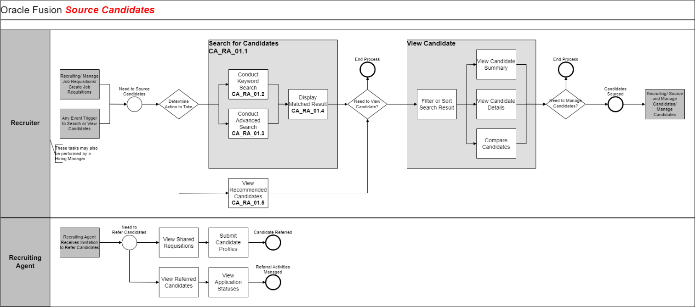



### Process Description

The above flow shows a process flow diagram to source candidate by Recruiter / Agency.

**Process Input**

Information to Create Candidate such as:

Candidate Details

Document Attachment (If Any)

**Process Output**

New Candidate will be created in system.

#### Process Step Description

|  |  |  |
| --- | --- | --- |
| **Process Step** | **Process Description** | **Process Type** |
| **CA_RA_01.1** | Initiator can search the candidates in their respective Candidate pools (Here Initiators are Recruiter & Agency) | System |
| **CA_RA_01.2** | Initiator will enter the keyword details and can search for the candidate | System |
| **CA_RA_01.3** | Initiator will process the advance search | System |
| **CA_RA_01.4** | Initiator will refer the matching result candidate. | Manual |
| **CA_RA_01.5** | In case Initiator decides to continue with the decision, will add more details in the profile.  In case Initiator decides to continue without addition of any further details, the process gets completed with the basic details provided | System |

## Candidate Application by Employee via Internal Job Portal

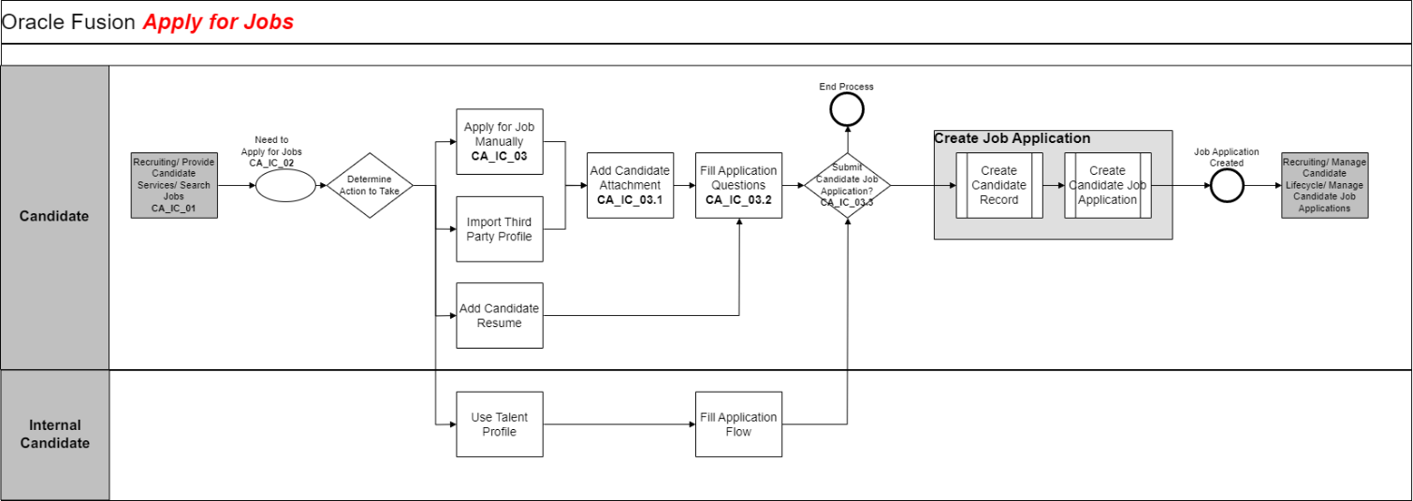



### Process Description

The above flow shows a process flow diagram to search for the job from internal career portal and submit the job application by Employee.

**Process Input**

Information for Job Application such as:

Candidate Personal Information

Candidate Profile data

Add Attachment if any.

**Process Output**

After completion of the process New Job Application will be created into the system

#### Process Step Description

|  |  |  |
| --- | --- | --- |
| **Process Step** | **Process Description** | **Process Type** |
| **CA_IC_01** | Requisition is posted on job boards. Ref.- CA_JR_11.1 | System |
| **CA_IC_02** | Employee will search and select the Job Requisition | System |
| **CA_IC_03** | Employee can either apply for the job or copy and share the link to others or can cancel the entire process. | System |
| **CA_IC_03.1** | Employee will attach supporting documents like CV mandatorily. | System |
| **CA_IC_03.12** | If employee applies for the job application, he will fill the job application questions. | System |
| **CA_IC_03.3** | Employee will submit the transaction. | System |
| **CA_IC_03.4** | Employee will receive the Confirmation message | System |

## Candidate Application by Candidate (External Career Site)



### Process Description

The above flow shows a process flow diagram to search for the job from external career portal / LinkedIn and submit the job application by Candidate.

Candidate application flow is the forms and list of blocks that the candidate fills while applying for a job. For applying for a job, the candidate follows the following flow.

If the Candidate has already applied for a Job Requisition, then he/she can withdraw the application anytime if the candidate is no longer interested.

KCH will have several career sites as per the hospitals.

**Process Input**

Information for Candidate Application such as:

Candidate Personal Information

Candidate Profile data

Add Attachment if any.

**Process Output**

After completion of the process New Job Application will be created into the system

#### Process Step Description

|  |  |  |
| --- | --- | --- |
| **Process Step** | **Process Description** | **Process Type** |
| **CA_EC_01** | Candidate will go to the job boards like External career site to apply for the vacancy. | System |
| **CA_EC_02** | Candidate will search & select the Job Requisition | System |
| **CA_EC_03** | Candidate can Apply the Job requisition or share the same with anyone. | System |
| **CA_EC_03.1** | Candidates can share and copy the link of the job requisition. | Manual |
| **CA_EC_03.2** | Candidates can choose to cancel the entire process by clicking on cancel. | System |
| **CA_EC_03.3** | Apply for the Job Requisition candidate will enter the Email Id | System |
| **CA_EC_03.3.1** | Email Verification will be done by sending Verification code to email id | System |
| **CA_EC_03.3.2** | Candidate will upload supporting document like CV or miscellaneous document | System |
| **CA_EC_03.3.3** | After verification Candidate will have to fill all required details and pre-screening questions | System |
| **CA_EC_03.3.4** | Candidate will enter the E-signature (Candidates Full name). | System |
| **CA_EC_03.3.5** | Candidate will submit the transaction. | System |
| **CA_EC_03.3.6** | Application will be created once transaction is submitted | System |
| **CA_EC_03.3.7** | Candidate will receive the confirmation mail | System |

## Candidate Application by Recruiter



### Process Description

The above flow shows a process flow diagram convert the candidate to applicant by adding the candidate to Job Requisition by Recruiter/Agency.

Recruiter can perform various Actions once candidate is created in system like.

Add to Requisition – Add candidate to new Job requisition.

Add to Candidate Pool – Add a candidate to any Candidate Pool for future reference.

Add Interaction - Recruiter can record all Interaction details.

Send Invite – Send invite to apply for job requisition.

Convert Prospect – Convert Prospect to Job Application

Send Message – send message using Email id.

Update to not interested – Recruiter can update not interested in case candidate doesn’t want to apply for job and send a separate rejection email.

Delete Prospect- Recruiter can delete the candidate.

**Process Input**

Information for Candidate Application such as:

Candidate Personal Information

Candidate Profile data

Add Attachment if any.

**Process Output**

After completion of the process New Job Application will be created into the system.

#### Process Step Description

|  |  |  |
| --- | --- | --- |
| **Process Step** | **Process Description** | **Process Type** |
| **CA_R_01** | Recruiter will select the candidate which is already created in system ref. **CA_01_TC** | System |
| **CA_R_02** | Once Candidate is selected, Recruiter will perform the action, **Add to requisition** | System |
| **CA_R_03** | Recruiter will select the Requisition | System |
| **CA_R_04** | Recruiter will have a checkbox option to create job application on behalf of candidate. | System |
| **CA_R_04.1** | If Recruiter checks the checkbox to create job application on behalf of candidate, candidate will be added as an applicant. | System |
| **CA_R_04.2** | If Recruiter does not check the checkbox to create job application on behalf of candidate, candidate will be added as a prospect. | System |
| **CA_R_05** | Recruiter receives a confirmation message. | System |
| **CA_R_06** | If candidate is added as an applicant, candidate receives a “Provide Additional Info” Email. And if candidate is added as a prospect, candidate receives an Invitation Email. | Manual |
| **CA_R_07** | Recruiter can change the phase or state of a candidate. | Manual |

# Manage Candidate Application

## Manage Candidate Selection Process

In KCH selection process is to be implemented based on employee type i.e. Clinical and Non-Clinical.

Following points were agreed in the requirement gathering session.

* Few phases of the Candidate Selection Process will be optional.
* Offer and Move to HR Phases are Mandatory Steps in all CSP’s.

### Process Description

Candidate Selection Process is the selection process a candidate goes through before being selected.

#### Process Step Description

|  |  |  |
| --- | --- | --- |
| **Process Step Name** | **Process Description** | **Process Type** |
| **Ref.** | Recruiter will select the candidate from Candidate Job Application. Ref- CA_EC_01 | System |
| **Inbox** | Candidate will be reviewed and selected for screening | System |
| **New** | Candidate CV will be reviewed here | System |
| **Recruiter Review** | Candidate will be reviewed by recruiter | System |
| **Line Manager Interview** | Line manager interview will be scheduled and if candidate passes, he will be moved on to CXO interview | System |
| **CXO Interview** | Candidate will be interviewed and if he passes, he will be moved to Offer | System |
| **Offer (RMI)** | Once the candidate is moved to Offer stage. An RMI will be triggered to candidate to submit extra information. Offer is to be created here and drafted. Offer will be approved, accepted, and extended here. | System |
| **HR** | This will be the final stage of the process. After all the above processes the candidate will be moved to HR. | System |
| **Pending Worker (Onboarding Process)** | After Move to HR pending worker will be created in the system. | System |

## Offer RMI/Post Offer Pre-hire Onboarding.

### Pre-Offer RMI

Once the candidate moves to Offer stage, an email is triggered to candidate’s registered email address to provide few document details.

* Education Certificates
* Experience Certificates (as per mentioned in their CV)
* Passport
* Family Book (For UAE Nationals)
* Medical License (Clinical Staff)
* Proof of their current salary
* Emirates id (front and back)

### Post offer Pre-hire Onboarding

Upon candidate offer acceptance, Recruiter will move candidate to HR stage, An Auto RMI will be triggered to candidate to submit extra information.

Documents of the post offer pre-hire onboarding:

* Visa Copy
* Photograph (Passport Size, White Background)
* Certificate of Good standing (issued by the licensing authority)
* Data Flow or PSV report
* Valid BLS / ACLS
* End of Service Certificate / Experience Certificate (mentioned the Joining and Last Working Date)
* Cancellation of current MOH Facility license/NOC ( if working in UAE)
* Moh Evaluation
* Marriage certificate
* Birth certificate
* Spouse salary certificate
* Home country license and current license

#### Process Step Description

|  |  |  |
| --- | --- | --- |
| **Process Step** | **Process Description** | **Process Type** |
| CA_JO_01 | Candidate will verify the email address by system generated code. | System |
| CA_JO_02 | Submit supporting document of experience. | Manual |
| CA_JO_02.1 | Provide information of Gender, experience, and qualifications. | System |
| CA_JO_02.2 | E-signature | System |

# Manage Interview

## Schedule an Interview

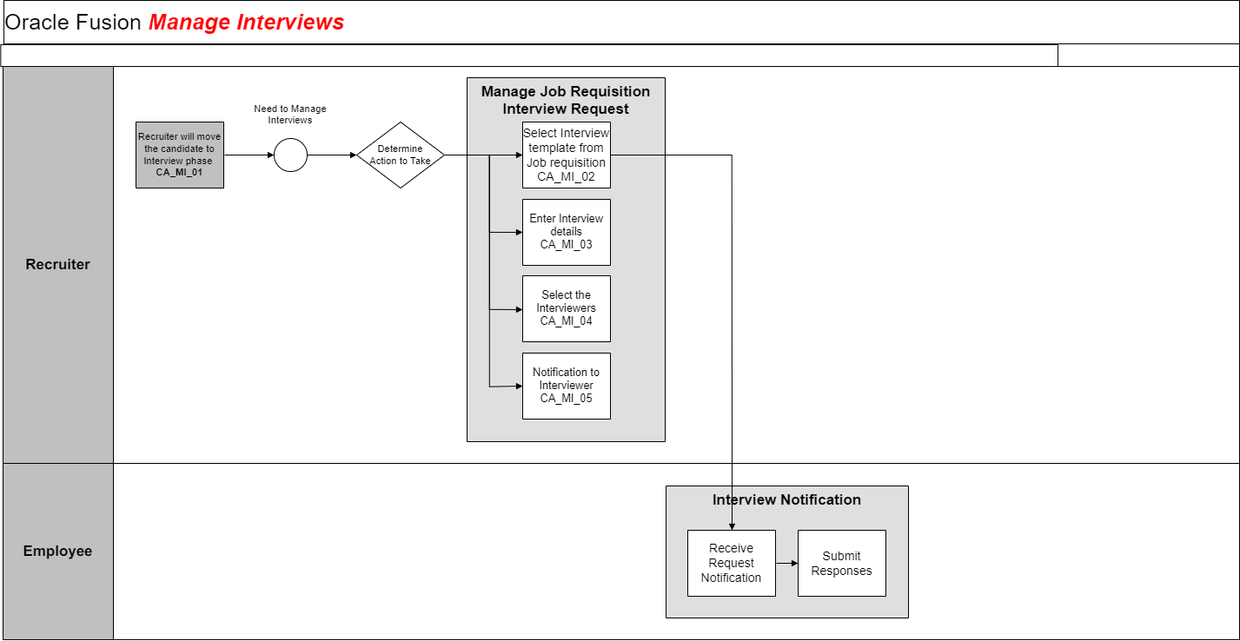



### Process Description

The above flow shows a process flow diagram to schedule an interview with the candidate.

#### Process step Description

|  |  |  |
| --- | --- | --- |
| **Process Step** | **Process Description** | **Process Type** |
| CA_MI_01 | Candidate will be selected at the interview phase in Candidate Selection Process. | System |
| CA_MI_02 | To schedule an interview Recruiter will add the Interview Template for the candidate attached to the Job Requisition. | System |
| CA_MI_03 | Recruiter will enter the Interview details as per the Interview Template | System |
| CA_MI_04 | Recruiter will select the Interviewer and enter the details and save the form | System |

## Update and Cancel Interview



### Process Description

The above flow shows a process flow diagram to reschedule or cancel an interview with candidate.

**Process Input**

Information for Manage Interview such as:

* Updated Interview details

**Process Output**

* Recruiter will reschedule or cancel an interview.

#### Process Step description

|  |  |  |
| --- | --- | --- |
| **Process Step** | **Process Description** | **Process Type** |
| CA_IRC_01 | Recruiter will select the candidate | System |
| CA_IRC_02 | Recruiter will select the Scheduled Interview | System |
| CA_IRC_03 | Recruiter can either reschedule or cancel the interview. | Manual |
| CA_IRC_04 | Recruiter will update the interview details in case recruiter wants to Reschedule the interview | System |
| CA_IRC_05 | Recruiter will Submit the transaction | System |
| CA_IRC_06 | Notification will be sent to Interviewer and candidate in case of Reschedule or cancelation of Interview. | System |

# Interview Feedback Form

Score Guide: - Disqualifier (D) - Significant development needs (SR) - Mostly meets the requirement for position (MR) - Fully meets requirements for position (FR) - Exceeds requirements for position (ER)

|  |  |  |  |
| --- | --- | --- | --- |
| **Sr.no** | **Question (For Leading Self)** | **Question Type** | **Response Options** |
| 1 | Interview Type | Single Choice (LOV) | * Personal * Telephone * Videoconference |
| 2 | Academic Achievements | Single Choice (LOV) | * D * SR * MR * FR * ER |
| 3 | Work- related Experience | Single Choice (LOV) | * D * SR * MR * FR * ER |
| 4 | Language (English, Arabic) | Single Choice (LOV) | * D * SR * MR * FR * ER |
| 5 | Others | Free text |  |
| 6 | Patient/Customer orientation  ~Communicates clearly and efficiently  ~Shows empathy towards others  ~Displays respect and listens | Single Choice (LOV) | * D * SR * MR * FR * ER |
| 7 | Adaptability  ~ Copes well with ambiguity  ~ Demonstrates intercultural competence  ~ Demonstrates balanced behavior under stress. | Single Choice (LOV) | * D * SR * MR * FR * ER |
| 8 | Performance orientation  ~ Evidence a “can do” mindset  ~ Sets and reaches ambitious targets  ~ Is eager and able to solve complex problems | Single Choice (LOV) | * D * SR * MR * FR * ER |
| 9 | Leadership  ~ Creates a climate of high energy  ~ Gives clear guidance and direction  ~ Motivates team and invests time for coaching | Single Choice (LOV) | * D * SR * MR * FR * ER |
| 10 | Teamwork  ~ Creates partnerships with colleagues across functions and nationalities  ~ Supports other even when it is not part of her/his job | Single Choice (LOV) | * D * SR * MR * FR * ER |
| 111 | Interest for Kings  ~ Is engaged and enthusiastic about Kings  ~ Inspires trust and shows integrity  ~ Upholds shared values | Single Choice (LOV) | * D * SR * MR * FR * ER |
| 12 | JCI OR Any Accredation Experience  ~ overall knowledge in JCI or any Accreditation Facility  ~ International Patient Safety Goals  ~ Documtation and Audit | Single Choice (LOV) | * D * SR * MR * FR * ER |
| 13 | Scenario no. 1 | Free Text | * Rating: * D * SR * MR * FR * ER |
| 14 | Scenario no. 1 | Free Text | * Rating: * D * SR * MR * FR * ER |
| 15 | Scenario no. 1 | Free Text | * Rating: * D * SR * MR * FR * ER |
| 16 | Overall Strengths | Free Text |  |
| 17 | Develpment needs | Free Text |  |
| 18 | Comments | Free Text |  |
| 19 | Recommendation | Single Choice (LOV) | * Considered for position applied to * Rejected * Considered for alternative position |
| 20 | Alternative position considered (If applicable): | Free Text |  |

# Manage Job Offer

## Create Job Offer

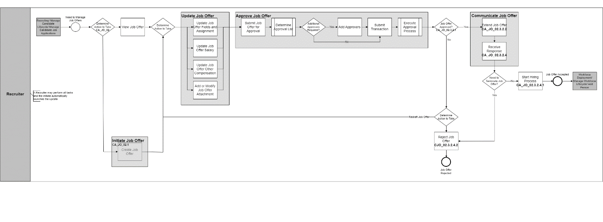



### Process Description

The above flow shows a process flow diagram to generate Job Offer letter for candidates,

**Process Input**

Candidate Job Offer Details

**Process Output**

Job Offer Letter will be generated upon the offer accepted by Candidate.

#### Process Step Description

|  |  |  |
| --- | --- | --- |
| **Process Step** | **Process Description** | **Process Type** |
| CA_JO_01 | Recruiter will receive the Application from candidate Application **Ref.- CA_01_TC** | System |
| CA_JO_02 | Recruiter will decide whether to consider candidate for job offer or not | Manual |
| CA_JO_02.1 | In case decision is yes Recruiter will create the Job Offer. | System |
| CA_JO_02.2 | Create the Job, Offer, Recruiter will Create the Job offer by filling the details | System |
| CA_JO_02.3 | Recruiter will select the Job Offer template from the drop-down option | System |
| CA_JO_02.3.1 | After filling all the details Recruiter will decide to Save & Close or submit the offer letter | Manual |
| CA_JO_02.3.1.1 | If recruiter save and closes the job offer, it will be saved as draft, and he can preview the job offer. |  |
| CA_JO_02.3.1.2 | Recruiter can edit the job offer by clicking on edit offer option. | System |
| CA_JO_02.3.1.3 | Recruiter will update the job offer details and again continue Ref- CA_JO_02.3.1 | System |
| CA_JO_02.3.2 | Approver will decide to Approve or Reject the transaction. | Manual |
| CA_JO_02.3.2.1 | In Case if the transaction is approved by all the stake holders, an approval confirmation will be sent to recruiter | System |
| CA_JO_02.3.2.2 | Once the offer is approved, the offer is extended to the candidate by recruiter | System |
| CA_JO_02.3.2.3 | Job Offer notification will be sent to the candidate | System |
| CA_JO_02.3.2.4 | Candidate will decide either to Accept or Reject the job offer | Manual |
| CA_JO_02.3.2.4.1 | In Case of acceptance Recruiter will receive the Job Offer Acceptance notification. And candidate will receive a notification to prepare all required document for pre joining process. | System |
| CA_JO_02.3.3 | If Transaction is rejected by Approver, then notification will be sent to Recruiter for further action. In Case recruiter wants to redraft the job offer please follow steps from **CJO_02.3.1.2** onwards. | System |
| CJO_02.3.2.4.2 | If Job Offer is declined by Candidate, then notification will be sent to recruiter for further action. | System |

## Job Offer Fields

|  |  |  |  |  |
| --- | --- | --- | --- | --- |
| Section | Field Name | Field Type | Mandatory | Values |
| When and why | When is the employee start date | Date | Y |  |
| When and why | Legal Employer | Drop Down | Y | All list of Legal Entities, the default value will be from Requisition |
| When and why | Action | Drop Down | Y | Add Pending Worker |
| When and why | Employee type | Drop Down | Y | * Contingent Worker * Employee |
| Assignment Info | Business Unit | Drop Down | Y | All list of Business Unit, the default value will be from Requisition |
| Assignment Info | Position | Drop Down | Y | All list of Business Unit, the default value will be from Requisition |
| Assignment Info | Grade | Drop Down | Y | Defaulted from Position |
| Assignment Info | Department | Drop Down | N | Defaulted from Requisition |
| Assignment Info | Location | Drop Down | Y | Defaulted from Requisition |
| Assignment Info | Regular or Temporary | Drop Down | N |  |
| Assignment Info | Assignment Standard Working hours | Text box | N | Textbox with dropdown for time unit i.e.   * Daily * Weekly * Biweekly * Semi monthly * Monthly * Yearly |
| Assignment Info | Probation Period | Text box | N | Textbox with dropdown for time unit i.e.   * Hours * Days * Weeks * Months * Years |
| Assignment Info | Notice Period | Text box | N | Textbox with dropdown for time unit i.e.   * Hours * Days * Weeks * Months * Years |
| Assignment Info | People Group | Drop Down | Y | * Direct * Indirect * CBD * CBD Visiting |
| Contract Info | Type | Drop Down | N | * Limited * Unlimited |
| Contract Info | Initial Duration | Text Box | N | Textbox with dropdown for time unit i.e.   * Hours * Days * Weeks * Months * Years |
| Contract Info | Contract End Date | Defaulted from Initial Duration | N |  |
| Offer Team | Hiring manager | Drop Down | N | Defaulted from Requisition |
| Offer Team | Recruiter | Drop Down | N | Defaulted from Requisition |
| Offer Team | Add Collaborator type | Drop down | N | Defaulted from Requisition |
| Payroll Info | Payroll | Drop down | Y |  |
| Salary | Salary Basis | Drop Down | Y |  |
| Salary | Salary Amount | Text Box | Y |  |
| Salary | Annual salary | Defaulted from salary Amount | N |  |
| Salary | Grade name | Defaulted | N |  |
| Salary | Next Salary review date | Date | N |  |
| Comments & Attachments | Offer comments | Text box | N |  |
| Comments & Attachments | Internal Documents | Attach file here | N |  |
| Additional Info | PLP | Text Box | N |  |
| Additional Info | Annual Leave | Text Box | N |  |
| Additional Info | Onboarding Specialist | Drop Down on basis of job family will be populated (Nursing, Administrative and Physician) | N |  |
| Additional Info | Onboarding Specialist Email | Drop Down on basis of job family will be populated (Nursing, Administrative and Physician) | N |  |
| Additional Info | Position Budgeted/ Unbudgeted | Drop Down | N | * Position Budgeted * Position Unbudgeted * Business case |
| Additional Info | Reason for hiring | Drop Down | N | * New Position * Replacement For |
| Additional Info | Leaver Details | Only if replacement for selected from Drop Down | Y | * Leaver details of the employees for which the person is getting replaced. |
| Offer Letter | Offer Letter | Drop Down | N |  |
| Offer Letter | Attachments |  | N |  |
| Offer Letter | Candidate job application language | Prefilled Text box | N |  |
| Offer Letter | Expiration Date | Date | N |  |
| Offer Letter | Additional Text1 | Free text field | N | It can be used in case recruiter would like to add any addition details on Offer Letter |
| Offer Letter | Additional Text2 | Free text field | N | It can be used in case recruiter would like to add any addition details on Offer Letter |
| Offer Letter | Candidate facing document | Drag And drop | N |  |

## Job Offer Template

**The job offer template required is as follows. Based on our initial requirement gathering, a Unified offer letter will be configured.**

# Candidate Management and Pools

As the list of candidates in the recruitment system will increase day by day. The requirement of a good candidate management system is a must. Considering these easy-to-use tools will be implemented in the ORC solution which will help search and manage candidates for different business requirements.

## Candidate Search and View



### Process Description

The above flow shows a process flow diagram to search, and view required candidate.

#### Process Step Description

|  |  |  |
| --- | --- | --- |
| **Process Step** | **Process Description** | **Process Type** |
| CS_CV_01 | Recruiter will have access to candidate files. Recruiter can do a Keyword Search / Advance search | System |
| CS_CV_02 | System will generate the result based on the search result which was selected by the recruiter | System |
| CS_CV_02 | If the recruiter wants to view the candidate, then the recruiter can click on the candidate file. | System |
| CS_CV_03 | There is different action recruiter can do on the candidate file.   1. View Candidate Summary 2. View Candidate Details 3. Compare Candidates | System |
| CS_CV_04 | Candidate can be sorted using options like   1. Relevance 2. Last Name | System |
| CS_CV_05 | Once the candidate is searched, recruiter can Manage the candidate. Management of candidate and its actions are mentioned in the above process flow | System |

## Manage Candidate Pool



### Process Description

The above flow shows a process flow diagram to manage candidate pool.

#### Process Step Description

|  |  |  |
| --- | --- | --- |
| **Process Step** | **Process Description** | **Process Type** |
| CA_CP_01 | Recruiter can do following actions on the candidate pool.   1. Create Candidate Pool 2. Update Candidate Pool 3. Share Candidate Pool 4. Delete Candidate Pool | System |
| CA_CP_02 | Recruiter can now add the candidate to the candidate pool or the requisition | System |

# Move to HR

Once the candidate is moved to HR it will be converted as Pending Worker in System and it will be considered as Hired in Oracle Recruitment Cloud. Upon converting Candidate to Pending Worker, Pre-Boarding checklist will be triggered, and task will be assigned to the pending worker as defined in Checklist.

# Access and Approval Matrix

Following is the access and approval matrix for transactions:

The data is secured in Cloud using Data Security Profiles. There are different roles in Cloud which have access to different sets of data and define which actions can be performed by which role.

## Access Matrix

Access matric have all the information about the access for the business pertaining stakeholders. What a stakeholder can perform and deliver would be based on the access matrix.

|  |  |  |
| --- | --- | --- |
| **Role Name** | **Key Responsibility** | **Provisioning Rules** |
| Hiring Manager | - View own Requisition  - Create Requisition  - View Candidate Job Applications | Manually |
| Recruiter | - View own Requisition and their member who are direct reporting to them  - Create Requisition  - Search all Candidates  - View Candidate Job Applications  - Move Candidate in Selection Process  - View Job Offer  - Create Job Offer  - Send Message to Team  - Add Interaction  - Add to Candidate Pool  - Manage Interviews  - Collect Feedback  - Manage Campaigns  - Manage Candidate Pool | Manually |
| Recruiting Administrator | - Manage Content Library (Offers, Ad-hoc email templates, Statements, etc.)  - Manage Questions  - Manage Requisition Templates  - Upload updated offer Template | Manually |
| Recruiting Manager | - View all Requisitions  - Create Requisition  - Search all Candidates  - View Candidate Job Applications  - Move Candidate in Selection Process  - View Job Offer  - Create Job Offer  - Send Email  - Add Interaction  - Add to Candidate Pool  - Collect Feedback  - Manage Campaigns | Manually |

## Approval Matrix

This part of the of the document will have the decision makers information. Approval matrix would specific condition-based rule to route to the accountable users based on grade, position, and budgeted/non-budgeted position parameter.

|  |  |  |  |  |  |  |  |
| --- | --- | --- | --- | --- | --- | --- | --- |
| **Transaction** | **Approval Routed to Hiring manager / Recruiter AOR** | **Initiator** | **Approval 1** | **Approval 2** | **Approval 3** | **Approval 4** | **Approval 5** |
| Job Requisition Approval | Requisition raised by Line Manager and submitted by Recruiter | Recruiter |  |  |  |  |  |
| Offer Approval | Recruiter submits the job offer | Recruiter | Rey | CXO (Department Head) | CPO | CFO | CEO |

# Onboarding

**To be Given**

# Notifications

Following are the notifications required as per the discussed and requested during CRP-1 sessions.

# Deliverables Source

This document is designed based on the HLA discussion with the key user and business decision makers. A requirement analysis document is attached for reference and any changes are subject to business decisions.

# Sign Off Sheet

|  |  |
| --- | --- |
| Project Name |  |
| Project Manager |  |
| Date | 18th Oct 2023 |
| KCH Recruitment policy |  |

**Legend**

* Yes (**Y**) response implies that the deliverable is approved.
* No (**N**) response implies that the deliverable is rejected with reasons and justification.
* Yes, with Notes (**YN**) response implies that the deliverable is approved with the required modification documented in that section.
* Remark: Stakeholder authorized personnel Sign-off shall not relieve the Vendor of his obligation to perform the work in accordance with the Contract document.

|  |  |  |
| --- | --- | --- |
| No | Description | Type |
| 1. | **KCH ORC Implementation SDD Sign Off** | **Document** |
|  | | |

**Stakeholders’ Approval**

|  |  |  |  |  |
| --- | --- | --- | --- | --- |
| No. | Stakeholder Name | Group | Signature | Signed Off?  YES No |
|  |  |  |  |  |
|  |  |  |  |  |
|  |  |  |  |  |
|  |  |  |  |  |
| **YES, with the following notes** | | | | |